Sample Concentrator (visible)—ND400
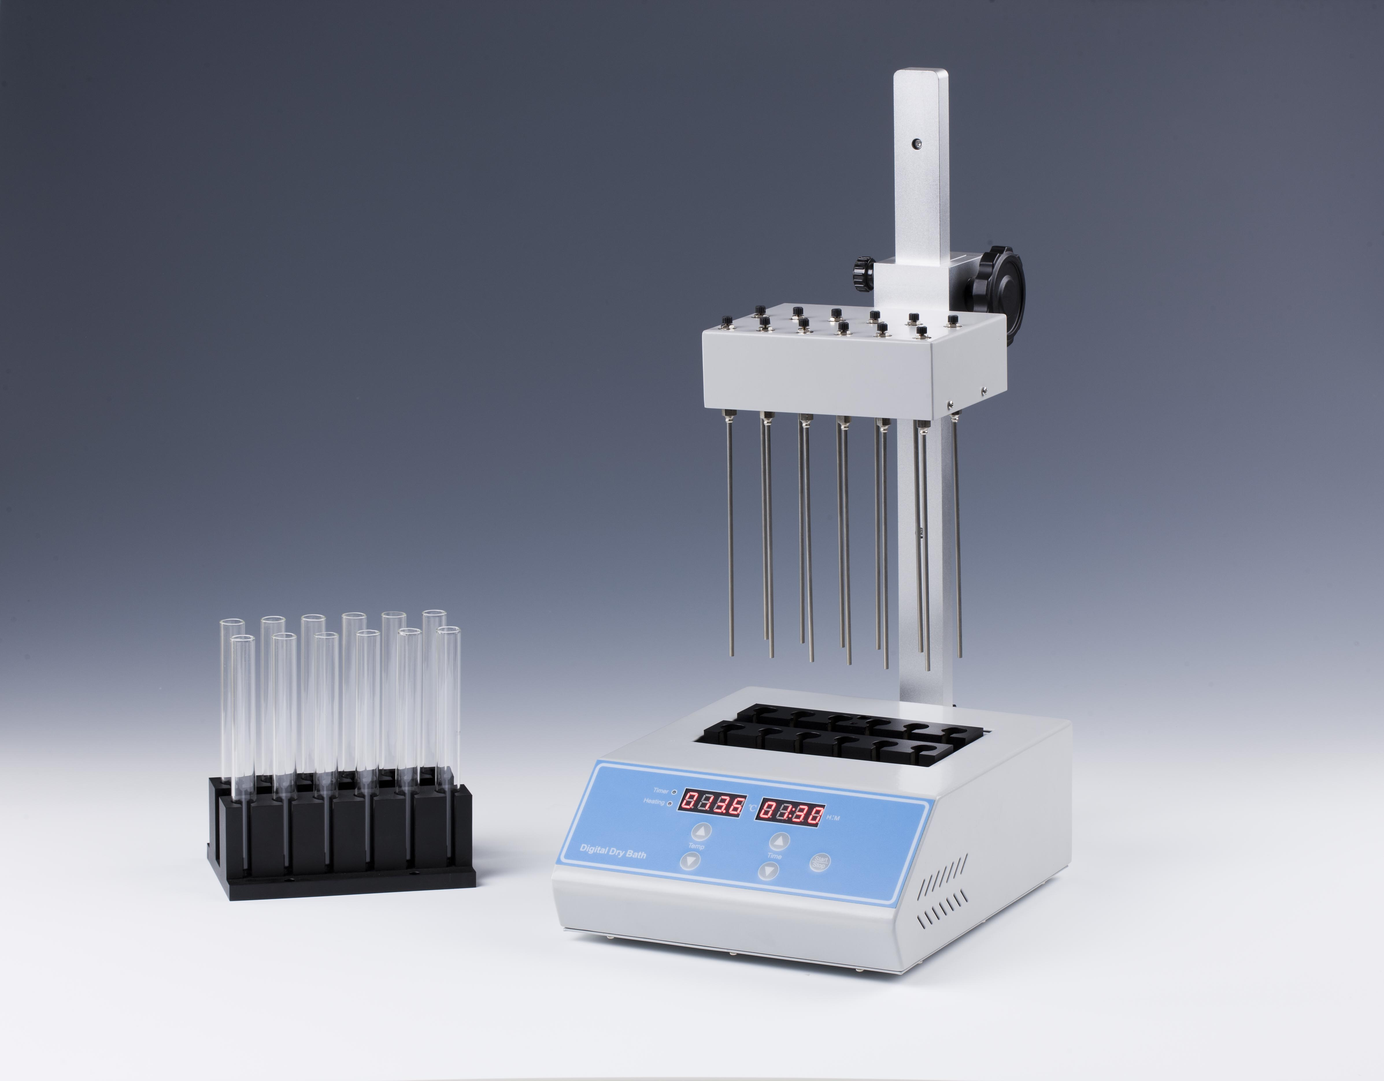
Description:
Sample Concentrator (visible) is a high precision temperature control instrument with microprocessor controlled and PID fuzzy controlled technique, its working principle is to blow nitrogen rapid, continuous on the heating surface of the sample. Instead of traditional water bath device, this adopts heat-conducting medium, which is high purity aluminum with good heat transfer. The Test tubes are held in a block, and blowing a large number of samples at one time.

Features:
◆ High precision and wide range of temp control.
◆ Blowing a large number of samples at one time.
◆ Blowing each sample independently.
◆ Amount of airflow can be adjusted.
◆With special slotting-design block, surface location of concentrated samples can be observed.
◆ Easy operation; safe and reliable to use.

Application fields
- Analysis of pesticide residues: vegetables, fruits, cereals, plant tissue.
- Environmental analysis: such as drinking water, groundwater and polluted water samples.
- Biological analysis: such as hormone analysis, sample preparation of liquid phase and gas phase and mass spectrometry analysis.
- Food and beverage: such as milk, wine, beer, etc.
- Pharmaceutical drug testing: such as traditional Chinese medicine pharmaceutical, drug screening.

Parameters:
Model | ND400
Temp range | RT.+5°C -160°C
Temp accuracy | ±0.5°C(@40°C)
Temp accuracy | ±1°C(@120°C)
Temp uniformity | ±0.5°C
Display accuracy | 0.1°C
Time Range | 1-99h59min/∞
Heating time | ≤15min(25°C to 160°C)
Max gas usage | 15L/min
Max gas pressure | 0.1Mpa
Block qty | 1
Max power | 500W
Voltage | 220V or 110V 50/60Hz
Dimension(mm) | 260x220x475
Weight(kg) | 7.3

Blocks
Type | Diameter | Depth | Capacity
RC02 027 001 | 10.5mm | 50mm | 12
RC02 027 002 | 12.5mm | 50mm | 12
RC02 027 003 | 13.5mm | 50mm | 12
RC02 027 004 | 15.5mm | 50mm | 12
RC02 027 005 | 16.5mm | 50mm | 12
RC02 027 006 | 19.5mm | 50mm | 12
RC02 027 007 | 20.5mm | 50mm | 12

